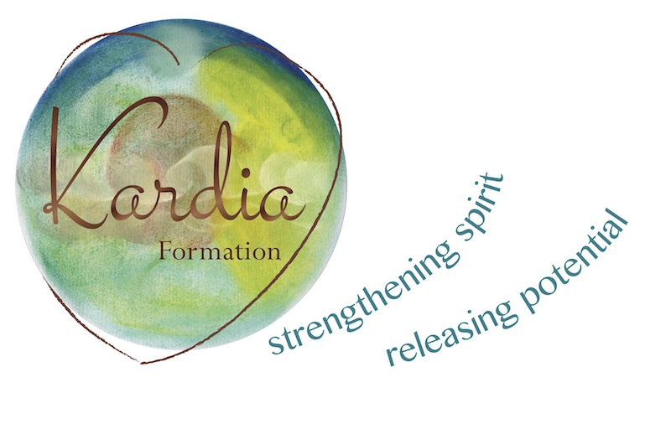
Kardia Formation Pty Ltd
at Stirling Theological College
44 – 60 Jacksons Rd,
Mulgrave, VICTORIA 3170
AUSTRALIA
enquiries@kardia.com.au
www.kardia.com.au

APPLICATION FOR ADMISSION
HEART WISDOM: INTEGRATED FORMATION FOR
SPIRITUAL DIRECTORS IN THE IGNATIAN TRADITION
A two-year program for formation in the art of spiritual direction and giving the Ignatian Spiritual Exercises. Please complete this application form, including a spiritual biography and send it by email to bernadette.miles@kardia.com.au and marlene.marburg@kardia.com.au . Upon receipt of your application you will be contacted to attend an interview with the course directors via Skype or at our office in Hawthorn. Applications must be received by 30 November for the 2022/23 intake.
Name:
Residential Address:
Postal Address:
Email: Telephone:
Date of birth: Religious affiliation:

Please give a brief overview of your experience of making the full Spiritual Exercises (ie. when, where, how – individually directed, 30-day/30-week etc.):

Please list previous formation experiences (including academic qualifications, professional attainment, ministry and retreats made).

Please give a brief overview of why you would want to participate in this formation course with Kardia at this time:

What do you expect from the Heart Wisdom Program?

Spiritual autobiography (no more than four pages):

