Book Order Form
Strengthening Spirit—Releasing Potential: Spiritual Direction for Leadership and Organizational Development

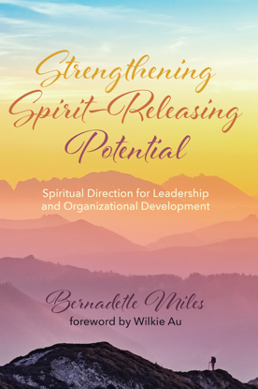
Have you ever wondered what releasing spiritual potential in the workplace might do for your organization? In today's climate of colossal and incredibly fast global change, the world needs new ways to develop discerning leaders to consciously lead our community of life into the future. Though there are many books on leadership, they rarely engage the importance and relevance of spiritual development and spiritual accompaniment in organizational discernment and leadership development. Spiritual formation through spiritual direction has the potential to transform the way we lead organizations in secular and religious settings.

"Linking cutting edge organizational thinking with Ignatian spiritual direction, which assumes the implicated order of a divine creation, she shows how leaders can open institutional paths which release untapped potential to transform their organizations in making real differences in the world, particularly when gripped by crises."
--John Bazalgette, founding member of The Grubb Institute
"It is rare indeed to find a book in which in-depth scholarship, skilfully integrated across multiple disciplines, is charged with the sparks of stardust that illuminate whole new horizons. Dr. Miles has achieved this in remarkable measure. Her book is an essential companion, inspirer, and empowerer of all who engage in roles of authentic and holistic leadership in humanity's quest to become the best we can possibly be in whatever field we serve."
--Margaret Silf, author and retreat facilitator, Scotland

Please Send …………… copies of @ $27 per copy + postage and handling of $8 in Australia – please contact Bernie for overseas postage costs.

Total amount of $ ……….. has been paid by direct credit to:

Account Name: Bernadette Miles
BSB: 013345
Account No: 544359097

ANZ Bank – 199 High Street Kew, Vic 3101
SWIFT/BIC code is ANZBAU3M.

Send books to:

Name:

Email Address:

Postal Address:

Return by email to : bernadette.miles@kardia.com.au

