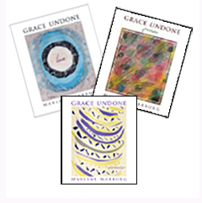
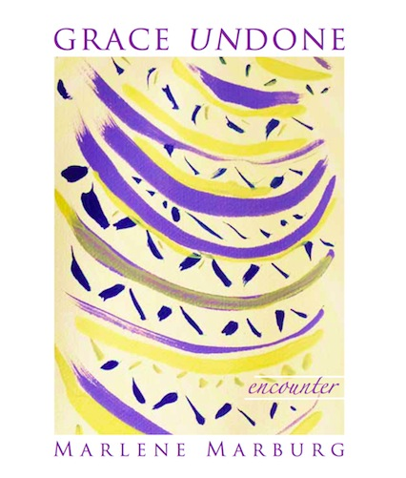

Grace Undone: Encounter
is the final gift quality book of 149 pages in the series Grace Undone.

As a series, the three books are companions to the prayer of the Seasons of the Spiritual Exercises of Saint Ignatius. Individual books are complete works in themselves. Grace Undone. Encounter includes imaginative contemplations on Gospel-texts as well as poems on life and Mystery. The book offers parallel scriptural texts for many of the poems.

Marlene’s poetry is candid, disarming, intimate, discomfiting, courageous, consoling – I could go on… but its frame is built on the foundations of love and honesty. Her poems excavate the grace of God in her life, not in syrup-like greeting card sentiments – but by attending to lived experience and the sometimes hideous realities that contains, and sitting with, and in that pain, until the window whitens. Julie Mitchell

Dreams and Desires edited by Marlene Marburg is an 84-page square paper-back anthology of poems and prose which showcases the emerging consciousness of over 40 people from around the globe. When asked their dreams and desires in this changing world, the themes of love, justice, attentiveness and Mystery emerged as paramount. The heart-felt responses in poetry and prose will move the reader again and again.

But deep in the chaotic core of our being the imaginal cells are stirring, imagining all that could become, in the world of Not Yet.

Margaret Silf

And in a flash I see how with words or paint or feet our child-like efforts can convert our mythic hurt. And make our lives into a sweet song for the earth.
Laura Lewis-Barr

ORDER FORM
Thank you for your order
Marlene Marburg. PO Box 6024 Doncaster 3108, Australia

NAME: _________________________
ADDRESS;
_______________________________
NEW EDITION: an ordinary woman [ [ ] @ $15 + p & h
NEW Dreams And Desires:
[ ] @ $18 + p & h
NEW Grace Undone: Encounter [ [ ] @ $24 + p & h
Grace Undone. Love
[ ] @ $25 per copy + p & h
Grace Undone: Passion

[ ] @ $30 per copy + p & h
Grace Undone: Complete Series (3) [] [ ] Series @ $74 per series + p & h

POSTAGE AND HANDLING

AUSTRALIA add $5 per book
EUROPE, UK AND USA add A$10 per book
NEW ZEALAND AND ASIA add $7 per book
In Australia, please pay directly to BSB 183 334, Account No 119 563 625, Macquarie Bank, Melb. [include your name]
OVERSEAS Paypal
www.marlenemarburg.com.au
marlene.marburg@kardia.com.au
an ordinary woman

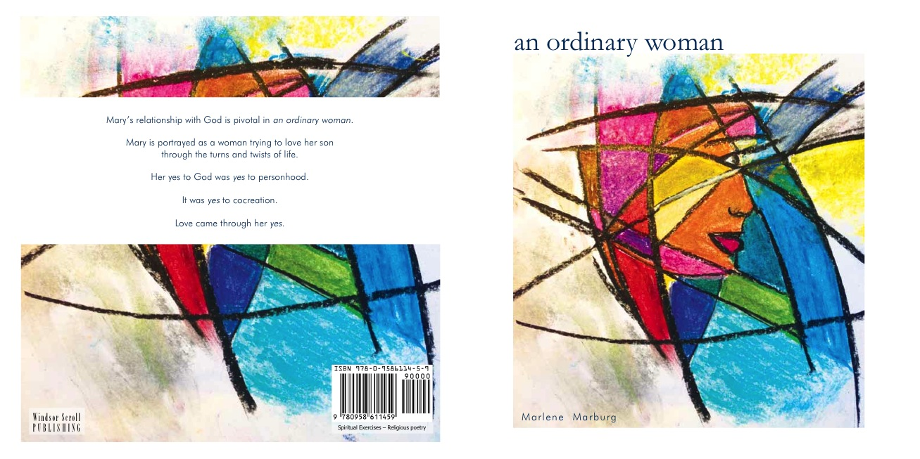

This second edition of an ordinary woman comes 12 years after the first. It uses the New International Version of the Bible. The layout, content and images are also changed. The spiritual orientation is contemporary and inclusive.

Mary’s relationship with God is pivotal in the book. Women and men alike can relate with Mary through her breadth of feelings and thoughts as well as her moments of dedication and passion wherein she experiences the companionship of God in many ways.

Thank you to all of you who have enjoyed reading the first edition of an ordinary woman. Thank you to those who have asked for the second edition. I hope you enjoy your journey with Mary and her family.

There is so much being said about Jesus. I am beginning to be overwhelmed. I am an ordinary girl. I do not have any special insights about being a mother or about educating Jesus in the Jewish laws and practices. You must have wanted an ordinary home for Jesus because that is what Joseph and I can offer (an ordinary woman, 28)

