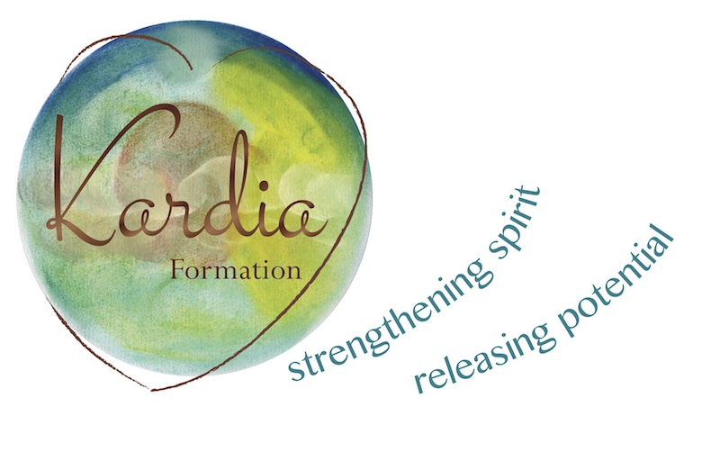
Kardia Formation Pty Ltd
Postal: PO Box 884
Mornington Vic 3931 Australia
enquiries@kardia.com.au
www.kardia.com.au

APPLICATION FOR ADMISSION
Heart Wisdom: Integrated formation in the Ignatian tradition.

A two-year program for formation in the art of spiritual direction and giving the Ignatian Spiritual Exercises. Please complete this application form, including a spiritual biography and send it by email to bernadette.miles@kardia.com.au and marlene.marburg@kardia.com.au . Upon receipt of your application you will be contacted to attend an interview with the course directors via zoom. Applications must be received by 30 November for the 2025/26 intake.
Name:
Residential Address:
Postal Address:
Email: Telephone:
Date of birth: Religious affiliation:

Please give a brief overview of your experience of making the full Spiritual Exercises (ie. when, where, how – individually directed, 30-day/30-week etc.):

Please list previous formation experiences (including academic qualifications, professional attainment, ministry and retreats made).

Please give a brief overview of why you would want to participate in this formation course with Kardia at this time:

What do you expect from the Heart Wisdom Program?

Spiritual autobiography (no more than four pages):

